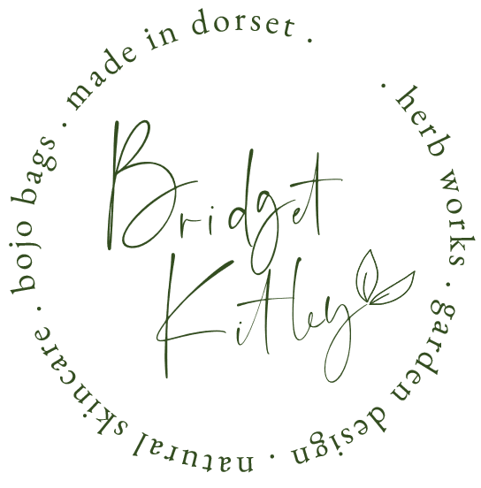

**Sewing alterations | Clothing Creations Price List 2023**

[bridgetkitley@gmail.com](mailto:bridgetkitley@gmail.com)

+44 78 5856 9096

**TROUSERS – Shorten/Lengthen**

Normal Hem £15.00

Blind Hem £17.00

Blind Hem with tape £18.00

Recreating Split Detail £21.00

Shorten with turn-ups/cuffs £21.00

Wide Bottoms | Silky fabric or those requiring hand stitching £22.00

Waist take-in or out £18.00 - 25.00

Taper half leg £20.00

Taper full leg £25 – 35.00

Pocket replacement from £15.00

**JACKETS & COATS**

Shorten Sleeves £26.00 - £ 35.00

Lengthen Sleeves £35.00

Shorten Jacket £30.00 - £45.00

Shoulders taken in from £45.00

Side & Back Tailoring £28.00 - £35.00

Coat Shorten from £35.00

Jacket & Coat Re-Lining from £75.00 - Please ask for a quote

**JEANS**

Shorten £15.00

Tapered half leg from £20.00

Full leg Taper £26.00 - £35.00

Patching £16.00 - £30.00

**WEDDING DRESSES ~ Please ask for a quote.**

Shorten from £70.00

Take in from £70.00.

**BRIDESMAIDS DRESSES ~ Please ask for a quote.**

Shorten from £30.00

Take in from £35.00.

**SKIRTS & DRESSES**

Shorten unlined from £16.00.

Shorten lined from £21.00.

Shorten – hand stitch from £26.00.

Skirt waist | Hip Tailoring from £26.00

Dress – Take in side seams unlined from £20.00

Dress ~ take in side seams | lined or zip up from £26.00

Lift Shoulders ~ unlined from £22.00

Lift Shoulders lined from £26.00

**SHIRTS**

Shorten Sleeves ~ no Cuffs £16.00

Shorten Sleeves ~ Shifting Cuff £22.00

Double Cuff made into single Cuff £22.00

Collar Turning £21.00

Taper from £20.00 - £25.00

Shorten length from £16.00

Add darts £16.00

**ZIPS**

Trousers from £18.00 - £20.00

Jeans £18.00

Skirts £18.00 - £20.00

Dresses £18.00 - £25.00

Dress lined £20.00 - £25.00

**\*Please note – we do not replace zips on padded Coats & Jackets**

**CURTAINS**

**\*Happy to make curtains when I can, please note that am limited due to space to small and medium sized curtains.**

Roman Blinds _ Make on request – Please ask for a quote

Pencil pleat curtains – Make on request – Please ask for a quote

Hand sewn interlined curtains – Make on request – Please ask for a quote

Shorten unlined from £22.00 per curtain

Shorten lined from £25.00 per curtain

Shorten padded – Hand stitched from £46.00 per curtain

Curtain relining from £50.00 per curtain

Thermal cotton bump interlining from £100.00 per curtain

**\*Please note, these prices are for up to 1 to 1.5 drops per fabric. Any additional drops - add £10.00 per drop.**

**SOFT FURNISHINGS**

Cushion Zip Replacement from £20.00

Patching from £15.00

Cushion Covers – 40cm x 40cm £27.00

45cm x 45cm £32.00

Piped Cushion Covers – Please ask for a quote

Swab Seat Covers – Please ask for a quote

**SCHOOL UNIFORMS LABELLING**

Per Garment £1.00

**CUSTOM MADE CLOTHING**

**\*Please ask for a quote**